**SAVEETHA SCHOOL OF ENGINEERING**

**SAVEETHA INSTITUTE OF MEDICAL AND TECHNICAL SCIENCES**

**CHENNAI-602105**

**RESTAURANT TABLE BOOKING SYSTEM**

**A CAPSTONE PROJECT REPORT**

*Submitted in the partial fulfillment for the award of the degree of*

**BACHELOR OF ENGINEERING**

**IN**

**COMPUTER SCIENCE AND ENGINEERING**

**Submitted by**

**Ch. Ajay(192210473)**

**Y. Sasi Kumar(192210474)**

**Under the Supervision of**

**Ms.L. Reetha**

**NOVEMBER 2024**

**DECLARATION**

We, **Ch. Ajay, Y. Sasi Kumar,** students of **Bachelor of Engineering in the Department** of Computer Science andEngineering, Saveetha Institute of Medical and Technical Sciences, Saveetha School of Engineering, Chennai, hereby declare that the work presented in this Capstone Project Work entitled **Restaurant Table Booking System** is the outcome of our own bonafide work and is correct to the best of our knowledge and this work has been undertaken taking care of Engineering Ethics.

(CH. Ajay (192210473))

(Y. Sasi Kumar (192210474))

Date: 23/11/2024

Place:Chennai

## CERTIFICATE

This is to certify that the project entitled **“Restaurant Table Booking System”** submitted by **Ch. Ajay, Y. Sasi Kumar** has been carried out under my supervision. The project has been submitted as per the requirements in the current semester of B.E Computer Science Enginnering.

**Supervisor ,**

**Ms. L. Reetha**

# Table of Contents

|  |  |  |
| --- | --- | --- |
| **S.NO** | **TOPICS** | **Page no:** |
| 1 | **Abstract** | **5** |
| 2 | **Introduction** | **5** |
| 3 | **Project Description** | **6** |
| 4 | **Problem Description** | **6** |
| 5 | **Tool Description** | **7** |
| 6 | **Operations** | 7 |
| 7 | **Approach / Module Description / Functionalities** | **8** |
| 8 | **Implementation** | **8-14** |
| 9 | **Output** | **15-18** |
| 10 | **Conclusion References** | **18-19** |

**ABSTRACT**

The Restaurant Table Booking System is an innovative web-based application designed to streamline the table reservation process for both customers and restaurant managers. This system enables users to view real-time availability, make reservations, and receive instant confirmation, providing a seamless and efficient booking experience. For restaurant managers, it offers a robust platform to manage reservations, optimize seating arrangements, and enhance customer service, thus improving operational efficiency and reducing the likelihood of errors. By integrating these functionalities, the system aims to boost customer satisfaction, increase table turnover rates, and ultimately drive business growth. Additionally, the system's analytics capabilities provide valuable insights into customer behavior and reservation trends, enabling restaurants to make data-driven decisions and tailor their services to meet customer needs. Through the implementation of cutting-edge technology and user-centric design, the Restaurant Table Booking System seeks to revolutionize the way restaurants handle reservations, positioning itself as an essential tool in the modern hospitality industry.

In the fast-paced restaurant industry, efficient table management and customer convenience are critical for success. This project presents the development of a comprehensive Restaurant Table Booking System designed to streamline the reservation process, improve customer satisfaction, and optimize restaurant operations. The system offers an intuitive web based interface for customers to view available tables, make reservations, and receive real-time booking confirmations. Key features include a dynamic booking calendar, customizable table layouts, and an admin panel that enables restaurant staff to manage bookings, update table availability, and send notifications for booking confirmations or cancellations. The system integrates analytics capabilities, providing valuable insights into peak booking times, customer preferences, and occupancy rates, aiding in strategic decision-making. Furthermore, the project incorporates automated alerts for table turnover times and reminders for customers, enhancing the overall dining experience. This capstone project aims to provide a scalable solution adaptable to various restaurant sizes, offering both efficiency in table management and a seamless reservation experience for customers. The system integrates analytics capabilities, providing valuable insights into peak booking times, customer preferences, and occupancy rates, aiding in strategic decision-making. Furthermore, the project incorporates automated alerts for table turnover times and reminders for customers, enhancing the overall dining experience. To ensure accessibility, the system is designed to work seamlessly across both desktop and mobile platforms, offering a consistent user experience. Additional security measures, such as encrypted data handling and user authentication, have been implemented to protect user information and enhance reliability. This capstone project aims to provide a scalable solution adaptable to various restaurant sizes, offering both efficiency in table management and a seamless reservation experience for customers.

**INTRODUCTION**

In today’s fast-paced digital age, the hospitality industry faces growing pressure to adopt innovative solutions that enhance customer satisfaction while improving operational efficiency. As dining out becomes an increasingly popular choice for both social and business gatherings, restaurants are striving to offer more convenient, flexible, and efficient reservation methods to meet the needs of a tech-savvy clientele. Traditional methods of table booking, primarily through phone calls or walk-ins, are prone to numerous issues, including scheduling errors, miscommunication, double bookings, and inefficient table utilization. Such issues not only frustrate customers but also hinder a restaurant's ability to manage resources effectively, especially during peak hours.

With the surge in online services and the convenience they provide, customers now expect to interact with restaurants digitally—whether it’s to view menus, check availability, or make reservations with just a few clicks. As a response to this growing demand, the Restaurant Table Booking System offers an online platform for effortless reservation management. This system allows customers to book tables directly through a website or mobile app, complete with real-time updates on availability, seating options, and special offers. By digitizing the booking process, restaurants can reduce dependency on manual reservation management, minimizing human error and offering a seamless experience for both customers and staff.

The proposed system is designed not only to handle reservations effectively but also to enhance operational workflow by providing restaurant managers with tools to monitor and analyze booking patterns. This data-driven approach allows managers to make strategic decisions, such as staffing adjustments, promotional offers, or reconfiguration of seating arrangements based on peak hours and customer preferences. Furthermore, the system’s automated notifications and reminders help reduce no-shows, leading to optimized table occupancy and increased revenue.

From the customer perspective, the ease of online reservations offers flexibility and transparency, contributing to a more satisfying dining experience. Users can easily modify or cancel reservations, view special events or deals, and even specify seating preferences, all of which enhance their overall dining journey. The platform's integration with mobile devices ensures accessibility and convenience, aligning with modern expectations for seamless and responsive user experiences.

In addition to benefiting customers, the system reduces the administrative burden on restaurant staff, allowing them to focus more on quality service delivery rather than juggling reservations. As more establishments transition towards digital reservation systems, having a comprehensive, user-friendly table booking platform is becoming essential to remain competitive in the market.

This project aims to design, develop, and implement an advanced restaurant table booking system, addressing both current and emerging demands within the hospitality sector. Through careful analysis and planning, the system will serve as a valuable asset in streamlining reservation processes, improving customer engagement, and supporting restaurant staff in delivering exceptional service. Ultimately, the Restaurant Table Booking System strives to set a new standard in table management, paving the way for a more efficient, customer-centric approach in the dining industry.

**Project Description:**

The Restaurant Table Booking System is a web application that allows customers to book tables at their preferred restaurants in advance. Key features include:

* User Interface: An intuitive interface for customers to select their desired date, time, and table. The interface is designed to be user-friendly and responsive, ensuring accessibility across various devices, including smartphones, tablets, and desktops.
* Real-Time Availability: Real-time updates on table availability to prevent double bookings and ensure that customers always have accurate information. This feature is critical in maintaining the system's reliability and trustworthiness.
* User Accounts: Options for customers to create accounts for faster bookings and to view past reservations. Returning users can enjoy a more personalized experience, with quick access to their booking history and preferences.
* Notifications: Email and SMS notifications to confirm bookings and send reminders. These notifications help reduce no-shows and ensure that customers are reminded of their reservations.
* Admin Dashboard: A comprehensive dashboard for restaurant managers to view, manage, and optimize table reservations. This tool allows managers to adjust seating arrangements, handle cancellations, and ensure optimal table utilization.

**Problem Description**

**Overview:**

The goal is to design and implement a web-based restaurant table booking system. This system will allow customers to book tables online, and restaurant staff to manage bookings efficiently. The system should handle customer reservations, track table availability, and provide a user-friendly interface for both customers and staff.

**Features:**

**Customer Features:**

○ **User Registration and Login:** Customers can create an account and log in to the system.

○ **Table Reservation:** Customers can select a date, time, and table for their reservation.

○ **View Booking Status:** Customers can view the status of their reservations.

○ **Cancel Booking:** Customers can cancel their reservations if needed.

**Restaurant Staff Features**:

* **Staff Login**: Restaurant staff can log in to the system.
* **Manage Reservations**: Staff can view all reservations, confirm bookings, and cancel them if necessary.
* **Table Management**: Staff can manage table availability and capacity.

**Tool Description:**

To develop this system, various tools and technologies will be utilized:

* **Front-End:** HTML, CSS, JavaScript, and frameworks like React or Angular for a responsive user interface. These technologies ensure that the front-end is dynamic, interactive, and provides a seamless user experience.
* **Back-End:** Node.js, Express.js, or Django for server-side logic. These back-end frameworks facilitate efficient handling of requests, data processing, and integration with the database.
* **Database:** MySQL, PostgreSQL, or MongoDB for storing reservation data. A robust database system is essential for managing and retrieving reservation data efficiently.
* **APIs:** Integration of third-party APIs for email/SMS notifications. These APIs ensure reliable and timely communication with customers.
* **Hosting:** Deployment on platforms like AWS, Heroku, or Digital Ocean. These cloud hosting services provide scalability, reliability, and security for the application.

**OPERATIONS**

The operations of the Restaurant Table Booking System can be divided into the following stages:

1. Customer Interaction: Users visit the website or app, search for their preferred restaurant, select a date and time, and make a reservation. This process is designed to be straightforward and quick, enhancing the user experience.
2. Reservation Processing: The system checks for availability, processes the reservation, and updates the database. This step ensures that reservations are accurately recorded and table availability is updated in real-time.
3. Confirmation and Notification: Customers receive confirmation via email or SMS. This confirmation serves as a record of the reservation and provides peace of mind to the customer.
4. Admin Management: Restaurant managers use the admin dashboard to view and manage incoming reservations, adjust seating arrangements, and handle cancellations or modifications. This feature helps managers maintain control over their reservation system and optimize table usage.
5. Data Analytics: The system provides insights into reservation trends, helping managers make informed decisions. Analytics can include peak reservation times, popular dining hours, and customer preferences, enabling better business strategies.

**Approach / Module Description / Functionalities:**

The system is divided into several modules, each handling specific functionalities:

1. User Module: Manages user accounts, authentication, and profile information. This module ensures secure access and personalized experiences for users.
2. Reservation Module: Handles the booking process, including date and time selection, table availability checks, and reservation confirmation. This core module ensures the smooth functioning of the booking process.
3. Notification Module: Manages email and SMS notifications for confirmations, reminders, and cancellations. Effective communication with customers is crucial for maintaining a high level of service.
4. Admin Module: Provides tools for restaurant managers to manage reservations, view analytics, and optimize seating. This module enhances operational efficiency and helps managers make data-driven decisions.
5. Reporting Module: Generates reports on reservation trends, peak hours, and customer preferences. These reports provide valuable insights for business improvement and strategic planning.

**IMPLEMENTATION**

**Registration:** The user fills out a registration form on the frontend (HTML/CSS/JS). The form data is sent to the web server (PHP) via an HTTP POST request. The PHP script validates the data and inserts the user information into the database.

**Login:** The user enters their credentials on the login form on the frontend. The credentials are sent to the web server (PHP) via an HTTP POST request. The PHP script verifies the credentials against the database and sets a session if successful.

**Restaurant Table Booking**: The logged-in user selects restaurant table booking options on the frontend. The booking details are sent to the web server (PHP) via an HTTP POST request. The PHP script processes the booking, stores the details in the database, and may interact with a restaurant table service API if necessary

**CODE**

**LOGIN.HTML:**

<!DOCTYPE html>

<html lang="en">

<head>

<meta charset="UTF-8">

<meta name="viewport" content="width=device-width, initial-scale=1.0">.

<title>Sign in page</title>

<link rel="stylesheet" href="styles.css">

</head>

<body>

<div class="sign">

<form action="login.php" method="post">

<label for="name">Username:</label>

<input type="text" id="name" name="name" required />

<label for="password">Password:</label>

<input type="password" id="password" name="password" required>

<input type="submit" value="Sign in" class="login">

</form>

<a href="projectreg.html">New User?</a>

</div>

</body>

</html>

**STYLE.CSS:**

body {

font-family: Georgia, 'Times New Roman', Times, serif; background-color: #f2f2f2;

background-image: url(https://cdnimg.webstaurantstore.com/uploads/blog/2019/4/restaurant-table-settings-formal

.gif);

background-position: 100%;

}

.sign{

width: 300px;

background-color: #f2f2f2; border-radius: 2px; padding: 3rem; display: block; margin: 0 auto;

}

.container { width: 350px; margin: 0 auto; padding: 2rem; background-color: whitesmoke; border-radius: 4px;

box-shadow: 0 2px 4px rgba(0, 0, 0, 0.1);

}

h1 {

text-align: center; margin-bottom: 2rem;

}

label {

display: block;

margin-bottom: 0.5rem; font-weight: bold;

}

input, select { display: block; width: 100%; padding: 0.5rem; margin-bottom: 1rem; border-radius: 4px; border: 1px solid #ccc;

}

button { display: block;

padding: 0.5rem;

background-color: #4CAF50;

color: #fff; border: none; border-radius: 4px; cursor: pointer;

}

.registerback{ background-size:cover; position:absolute; top:0; left:0;

height:100%; width:100%;

}

.reghead{ color:orange; font-family:"Caveat"; text-align:center; text-decoration:underline;

}

.formstyle{ color:black; font-style:italic;

background-image:url("https://png.pngtree.com/thumb_back/fh260/background/20220112/pn gtree-glass-morphim-effect-registration-banner-with-gradient-blue-image_934693.jpg");

padding:6px; margin-left:400px; margin-right:400px;

margin-bottom:20px;

}

.error{ color:red;

}

.login{

background-color:lightgreen; color:white;

border-radius:20px;

}

**LOGIN.PHP:**

<?php

$servername="localhost";

$username="root";

$password="";

$dbname="library";

$conn=new mysqli($servername,$username,$password,$dbname); if(!$conn)

{

die('Could not connect: '.mysqli_connect_error());

}

$u=$_POST["uname"];

$p=$_POST["pass"];

$sql="SELECT Reg_No,Uname,Password FROM student where Uname= '{$u}' ";

$result=$conn->query($sql);

if($result->num_rows>0)

{

while($row=$result->fetch_assoc())

{

if($row["Uname"]==$u && $row["Password"]==$p)

{

echo "You have been Successfully validated";

$conn->close();

header("refresh:3; url=page1.php");

}

else

{

echo "Credentials Wrong, Try again";

}

}

}

else

{

echo "User name given was not exist";

}

$conn->close();

header("refresh:3; url=home.html");

?>

**OUTPUT**

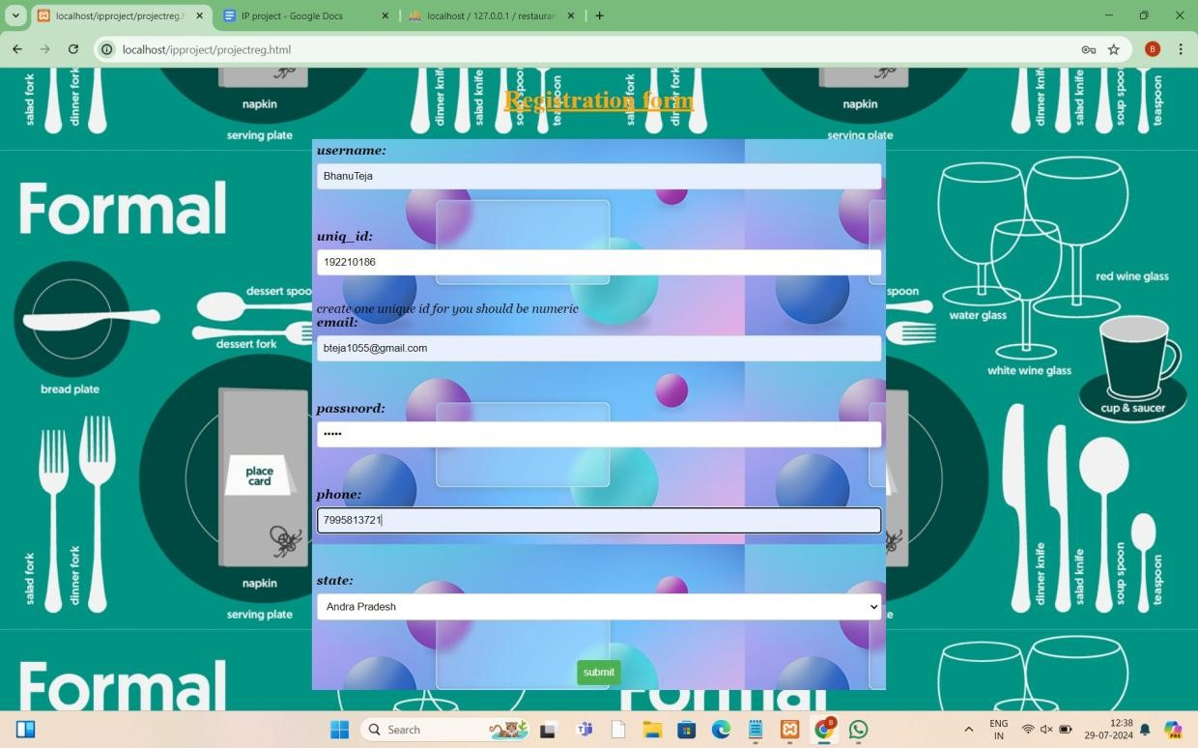

Fig 1: Registration Form

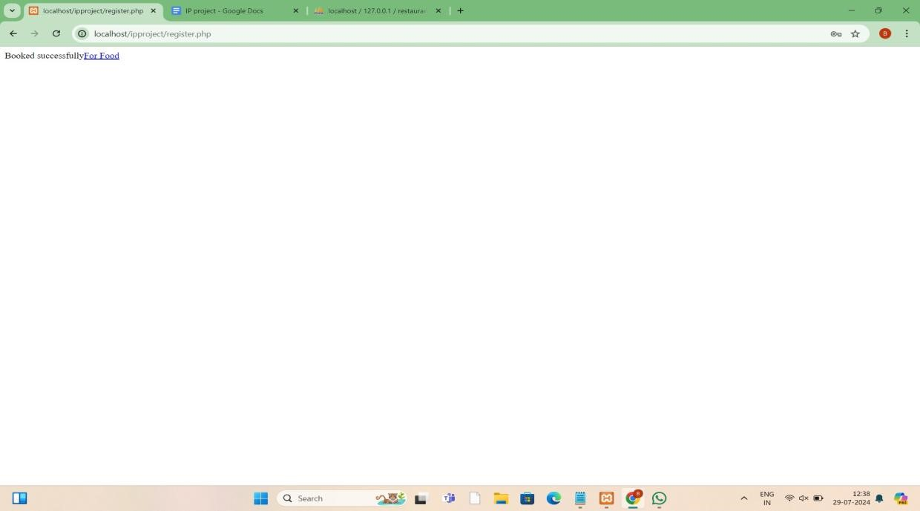

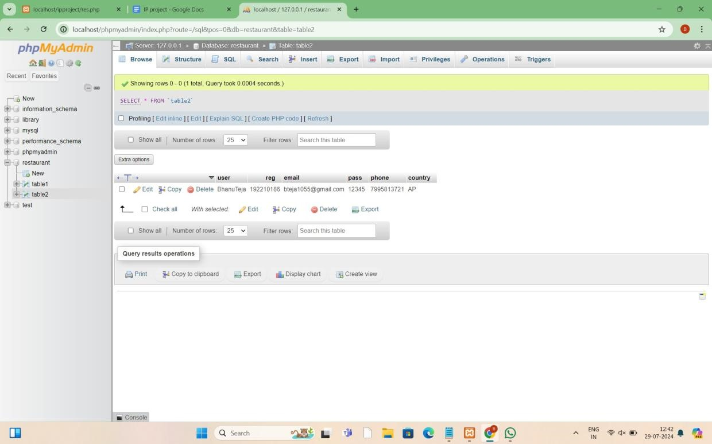

Fig 2: Database of Table 1.

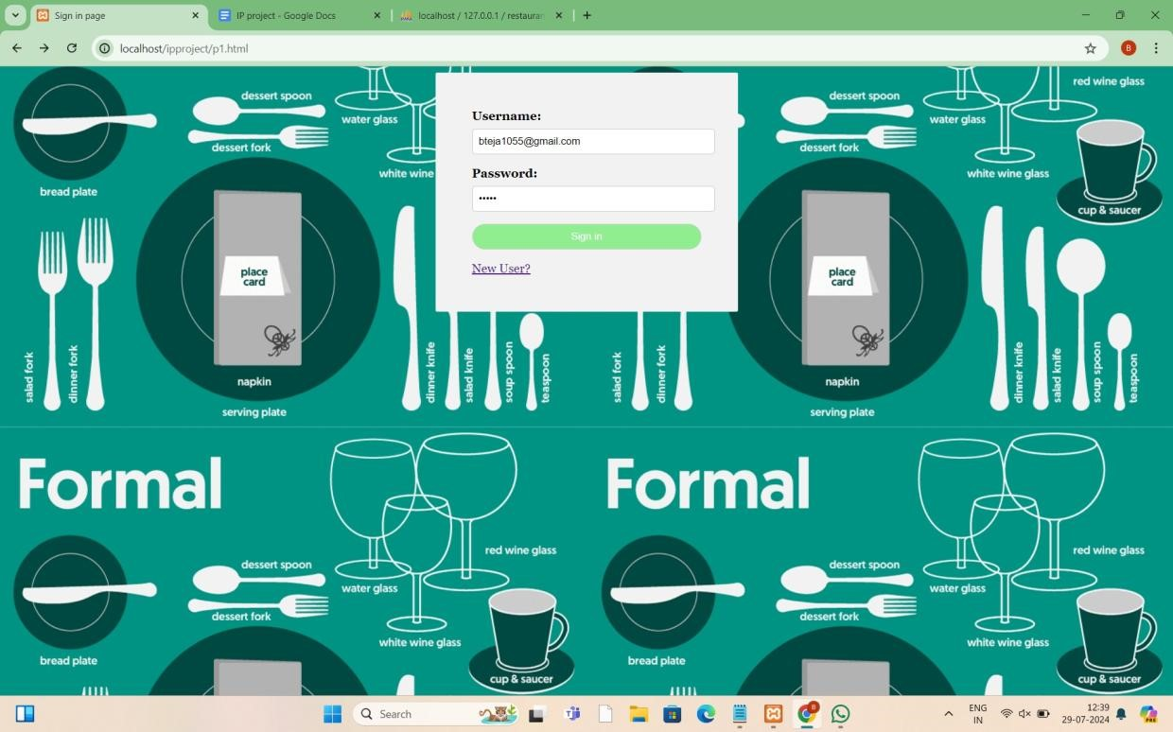

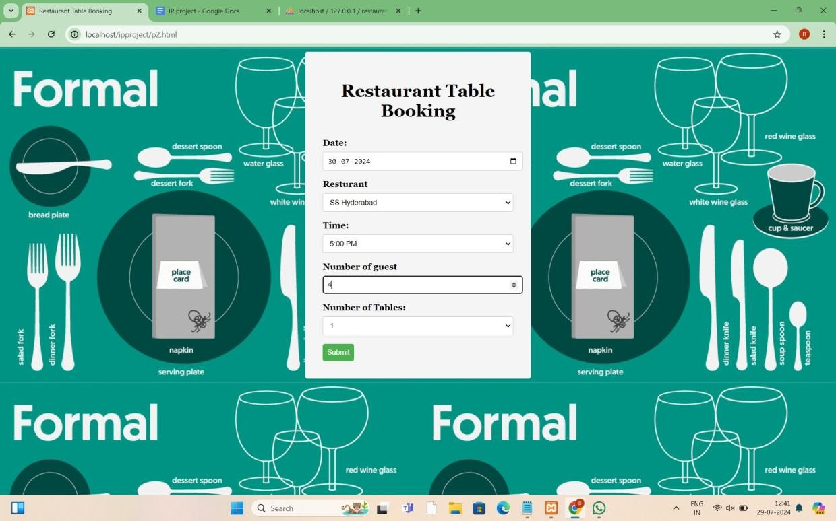

Fig 3: Table booking

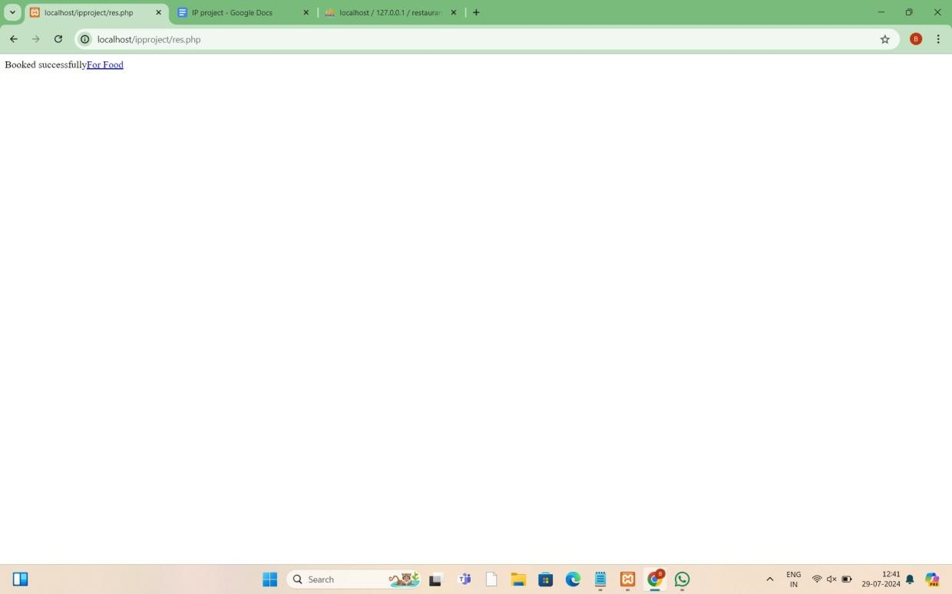

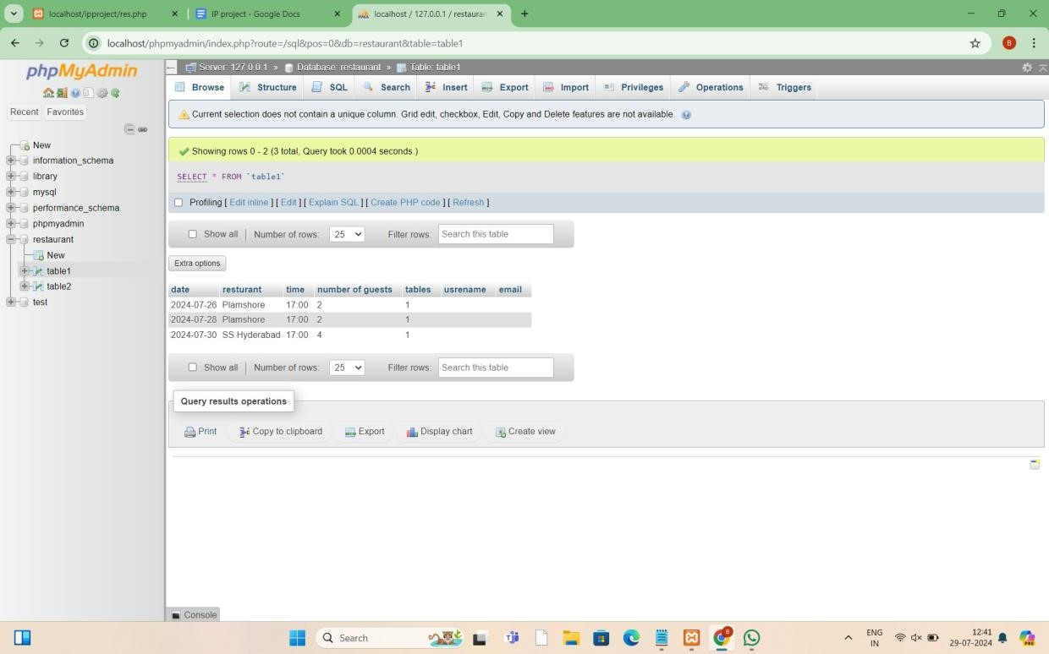

**CONCULSION**

The Restaurant Table Booking System is poised to revolutionize the way restaurants handle table reservations. By offering an easy-to-use platform for customers and a powerful management tool for restaurant managers, this system enhances efficiency, reduces errors, and improves the overall dining experience. As the hospitality industry continues to embrace digital solutions, this project represents a significant step towards modernizing restaurant operations and meeting the evolving needs of customers. The successful implementation of this system will lead to increased customer satisfaction, optimized restaurant operations, and ultimately, a boost in revenue and growth for the business.

**REFERENCES**

1. Kumar, B. Naveen, and B. Sai Varun. "Table booking and restaurant management system using android application (OPSS)." *International Journal of Engineering Applied Sciences and Technology* 4.12 (2020): 373-378.
2. Balabantaray, Sidhanta Kumar, et al. "Online Table and Menu Booking System for Restaurants."
3. Rarh, Fahim, et al. "Restaurant table reservation using time-series prediction." *2017 2nd International Conference on Communication and Electronics Systems (ICCES)*. IEEE, 2017.
4. Egigogo, Raji Abdullahi, et al. "Design and Implementation of Computerized Restaurant Table Booking System." *Ceddi Journal of Information System and Technology (JST)* 3.1 (2024): 47-55.
5. Kale, Sharyu, Parth Goti, and Reema C. Roychaudhary. "Online Table and Menu Booking System for Restaurants."
6. Ardiansyah, Muhammad Rizqi, et al. "The Website-Based Food Booking System Equipped with Real-Time Booking Status to Address Queuing Issues at Restaurants." *2021 International Conference on Electrical and Information Technology (IEIT)*. IEEE, 2021.
7. AL, Zuwaina Said AL Housni Said, et al. "Reserve your table: A mobile application for reservations in a restaurant." *Journal of Student Research* (2021).
8. Gregorash, Bill J. "Restaurant revenue management: apply reservation management?." *Information Technology & Tourism* 16 (2016): 331-346.
9. Sethi, Akash, et al. "Review paper on restaurant reservation and management." *International Journal Of Progressive Research In Engineering Management And Science (Ijprems)(pp: 141147)* (2022).
10. Soo, Huey Ling. Restaurant ordering and reservation system/Soo Huey Ling. Diss. University of Malaya, 2020